**ChronoNet: A Deep Recurrent Neural Network for Abnormal EEG Identification**

**Links:**

Colab Link: <https://colab.research.google.com/drive/1xj8ebZ7FVB_FF8ybSA_8IttDaqywYzc3>

Research Paper Link: <https://arxiv.org/abs/1802.00308>

Dataset Link: <https://data.mendeley.com/datasets/fshy54ypyh/2>

**Summary:**

This research paper introduces ChronoNet, a novel recurrent neural network (RNN) architecture designed for automated analysis of electroencephalogram (EEG) data. EEG analysis for brain-related disorders like epilepsy is traditionally manual and time-consuming, with low inter-rater agreement among clinicians. ChronoNet's innovative approach, inspired by image classification techniques, efficiently processes EEG data, distinguishing abnormal from normal brain activity. Tested on the TUH Abnormal EEG Corpus dataset, ChronoNet surpasses previous benchmarks, demonstrating its potential to improve diagnosis accuracy and reduce manual errors. Additionally, its domain-independent nature allows it to classify speech commands, showcasing its versatility.

**Recurrent Neural Network (RNN):**

Recurrent Neural Networks (RNNs) are a category of neural networks designed for handling sequential data of varying lengths. An RNN maintains a recurrent hidden state, and at each time step, it updates this state based on the current input vector (x(t)) and the previous hidden state (h(t-1)). This allows RNNs to capture dependencies and patterns in sequential data by considering information from previous time steps, making them suitable for tasks such as natural language processing and time series analysis.

Equation 1:

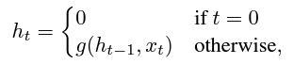

Where g is a nonlinear function.

Equation 2:



Classical RNNs update their recurrent hidden unit using Equation (2), which involves an affine transformation followed by a nonlinear activation function (e.g., sigmoid or hyperbolic tangent). However, this formulation suffers from the vanishing and exploding gradient problem over long sequences during training, making it challenging to capture long-term dependencies.

To address this issue, more advanced recurrent units have been introduced, such as Long Short-Term Memory (LSTM) and Gated Recurrent Unit (GRU). Both LSTM and GRU models are designed to mitigate the gradient problems and are superior to classical RNNs. In this paper, the authors opt for GRUs because they have fewer parameters than LSTMs, resulting in faster training times while still maintaining the ability to generalize effectively. The choice between LSTM and GRU remains an ongoing research question, but GRUs are preferred in this study for their efficiency and generalization capabilities.

**Gated Recurrent Unit (GRU):**

Gated Recurrent Unit (GRU) computes the current hidden state (h(t)) by performing a linear interpolation between an intermediate candidate hidden state (˜h(t)) derived from Equation (2) and the previous value of the hidden state (h(t-1)). The GRU employs two gates: an update gate (z(t)) that controls how much of the previous state should be overwritten, and a reset gate (r(t)) that determines how much of the previous state should be forgotten when computing the candidate hidden state.

This can be expressed mathematically as follows:

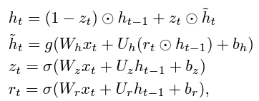

GRUs are designed to selectively update and retain information from previous time steps, allowing them to effectively capture long-range dependencies in sequential data.

**Method for training:**

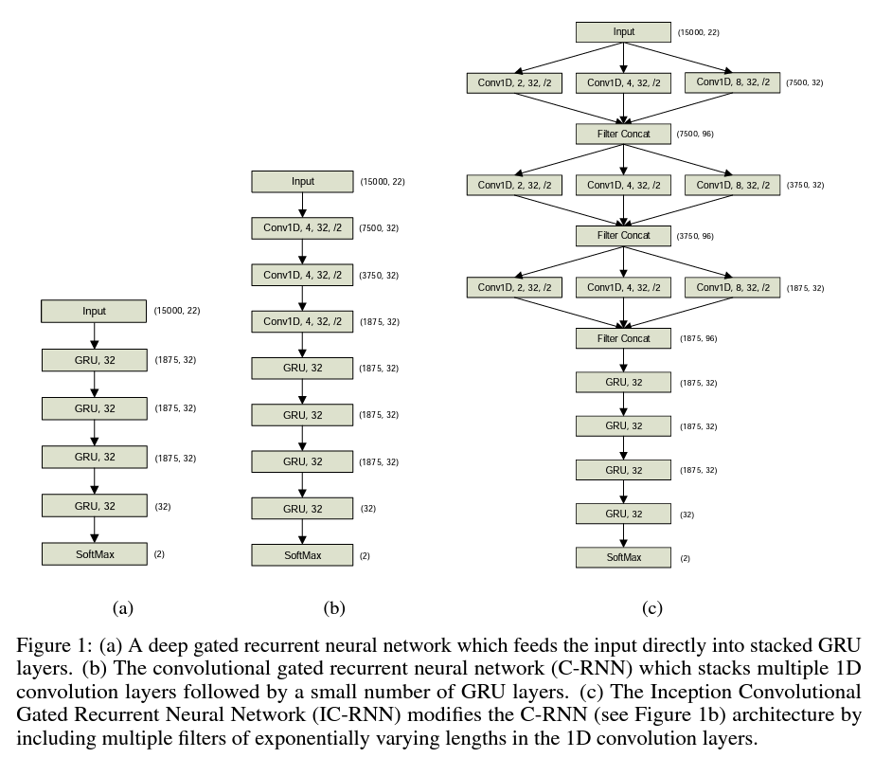

ChronoNet is an innovative architecture that combines modifications from previous networks (IC-RNN and C-DRNN) with the C-RNN to create a novel structure. This architecture involves stacking multiple Conv1D layers, each with various filter sizes, followed by multiple GRU layers that are densely connected in a feed-forward manner. The Conv1D layers with multiple filter lengths enable ChronoNet to extract and merge features from different timescales, offering flexibility for various tasks. Densely connected GRU layers help address the problem of vanishing or exploding gradients during training, allowing for the creation of deeper and more complex ChronoNet variants. This architecture is particularly designed for abnormal EEG classification, as depicted in Figure 2b. This combination of features enhances feature propagation, reuse, and model expressiveness. To the best of the authors' knowledge, this architecture is reported here for the first time.

**Feed Forward Implementation**

